CAP 492
Artificial Intelligence

Tutorial # 5

Q1:Problem formulation:

During an examination, an invigilator has to arrange six students in a way to make sure that the examination is properly conducted and no one cheats. 3 students have makeup in Mathematics, 2 students have makeup in Computer science and 1 student in physics. As shown in figure below, there exist 6 desks arranged into two rows and three columns.
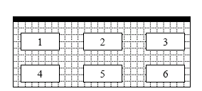

The problem for the invigilator is to arrange students so that students having the same makeup exam should not be neighbors (in the same column or in the same row for example neighbors of 5 are 2, 4 and 6). Furthermore, the student who has Physics exam is suspected of cheating, and hence should be in the first row (desk 1 or 2 or 3).

- Propose a formulation of the problem in term of CSP by specifying variables, domains and constraints.

- Propose a solution to help the invigilator.

Q2: Given the constraint graph below, answer the following questions:

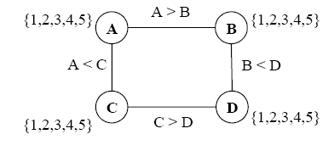

- Trace Arc Consistency (AC3) algorithm on this graph. Initially, the queue contains the following arcs: AB, BA, AC, CA, CD, DC, BD, DB

b) According to the obtained results, what can you conclude about the completeness of AC3

c) Using forward checking, find a solution to this problem. Hints:

- use MRV heuristic to select variables. In case of similarity, variables are selected according to the alphabetical order.
- Values are selected in ascending order.

Q3: Define in your own words the following terms: Constraint satisfaction Problem, Constraint, Backtracking search, and arc consistency.

Q4: How many solutions are there for Australia map coloring problem with three colors?

Q5: Consider the problem of constructing crossword puzzles: fitting words into a rectangular grid. The grid which is given as part of the problem specifies which squares are blank and which are shaded. Assume that a list of words (i.e. a dictionary) is provided and that the task is to fill in the blank squares using any subset of the list. Formulate this problem in two ways: as a general search and as a CSP.

